**Supplementary Assessment Report**

**DA No. 5.2020.247.1**

**144 Magellan Street Lismore**

**Introduction**

On 17 February 2021, the proposed development being, Development Application 5.2020.247.1, Panel reference PPSNTH-59, for the alterations and additions to a recreational facility (major) comprising the upgrading of two grandstands (Gordon and Crozier Pavilions), and a new Oakes Oval Grandstand, was deferred by the Northern Regional Planning Panel from determination pending further information.

Reason 1 for deferral requested a Draft Operational Management Plan that has been supplied by the Applicant and included as a separate document.

This supplementary report provides a response to the information requested in point 2 of the reasons for deferral.

A revised set of conditions has been provided to satisfy point 3. A separate document has been provided with all new conditions and amendments in red. Council Officers reports have also been attached with condition numbers in red indicating where the respective condition lies in the Draft Conditions.

Also provided as a separate document is an amended Assessment Report with amendments in red.

**Matter of potential land contamination**

Council’s Land Information System assessment identifies the Oakes Oval precinct and Lismore Tourist Caravan Park (adjoining lands immediately to the north) as a potentially contaminated land – historic use as a waste facility (landfill). As part of the assessment, and in response to the contaminated land notation an internal historic review was undertaken.

The waste facility ceased operation in the 1940’s and verbal information was relied upon with physical or digital records pertaining to the facility not forthcoming. The review concluded that the location of the former waste facility (landfill site) was located on lot 1 DP 636233, 50 Dawson Street Lismore, approximately 350 from the subject site. This land is currently occupied by the Lismore Tourist caravan park as illustrated by the image below.

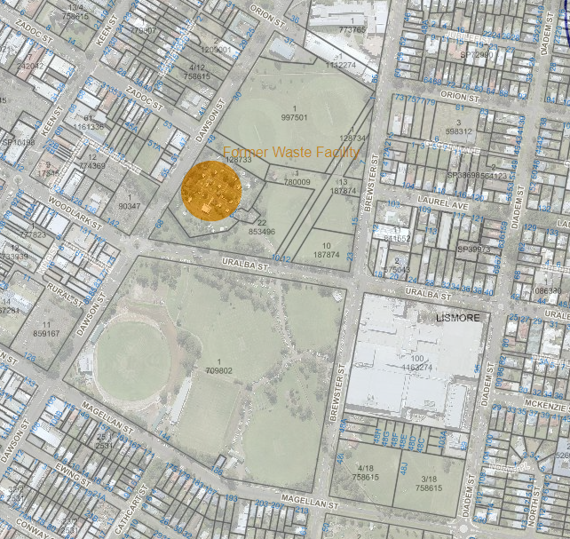

In response to this outcome, and adopting a precautionary position, an unexpected findings protocol was recommended to be implemented for the proposed development work. The requirement of an unexpected findings protocol has been expressly included in the following conditions of contest (as amended in red).

**Condition 15**

A Construction Management Program shall be submitted and approved in writing by Lismore City Council **prior to the commencement of work**. Any use of Council property shall require appropriate approvals prior to such work commencing. The program shall specifically address the following matters:

1. The proposed method of access to and egress from the site for construction vehicle, including the proposed method of traffic control, access routes through the Council area and the location and type of temporary vehicular crossing for the purpose of minimising traffic congestion and disruption to traffic flows and noise in the area, and provision for vehicles leaving the site in a forwards direction. (Access across public parks and open space reserves is prohibited.
2. An unexpected findings protocol for soil with potentially contaminated features that may be disturbed during excavation.
3. How access to neighbouring properties will be maintained at all times;
4. The proposed method of pedestrian management to comply with AS1742.3 and AS1742.10, including pram ramp details;
5. The proposed phases of construction works on the site, and the expected duration of each construction phase;
6. The proposed order in which works on the site will be undertaken, and the method statements on how various stages of demolition and construction will be undertaken;
7. The proposed method of loading and unloading excavation and construction machinery, excavation and building materials, formwork and the erection of any part of the structure within the site. The road is not to be used as a waiting area for trucks delivering to or awaiting pick up of materials;
   1. The location and operation of any on site crane (if required). On site cranage is a requirement of this consent. Mobile cranes if used shall be located wholly within the site or only utilised during the demolition and excavation phase, and in association with the establishment and removal of a site crane, removal of excavation equipment and the like;
   2. The proposed areas within the site to be used for the storage of excavated materials, construction materials and waste containers during the construction period;
   3. The proposed method/device to remove loose material from all vehicles and/or machinery before entering the road reserve, any run-off from the washing down of vehicles shall be directed to the sediment control system within the site;

All traffic control work and excavation, demolition or construction activities shall be undertaken in accordance with the approved Construction Management Plan and any conditions attached to the approved plan. A copy of the approved Construction Management Plan, and any conditions imposed on that plan, shall be kept on the site at all times and made available to any officer of Council upon request.

Notes:

1. Lismore City Council’s adopted fee for certification of compliance with this condition shall be payable on lodgement, or in any event**, prior to the issue of the relevant approval**.
2. Failure to provide complete and detailed information may result in delays. It is recommended that your Construction management Plan be lodged with Council as early as possible, as a minimum six (6) weeks’ notice is required to refer items to the Traffic Committee.
3. Dependent on the circumstances of the site, Council may request additional information to that detailed above.

***Reason:*** *To ensure appropriate measures have been considered for site access, storage and the operation of the site during all phases of the construction process in a manner that respects adjoining owner’s property rights and residential amenity in the locality, without unreasonable inconvenience to the community.*

**And condition 29**

All waste materials generated from construction and demolition works shall be managed in accordance with a site specific and contemporary ‘Hazardous Materials Risk Assessment Report’ prepared by an appropriate qualified person. Waste materials shall only be disposed at licensed waste management facilities capable of receiving the waste as classified under the NSW Department of Environment and Climate Change (EPA) guideline document ‘Waste Classification Guidelines: Part 1 Classifying Waste 2014’.

Site management of excavated soil shall follow the unidentified findings protocol contained as part of the approved Construction Management Program.

***Reason:*** *To protect the environment and manage wastes appropriately.*

**Flood Management Arrangements**

It was discussed in the meeting with the Panel that the inclusion of an evacuation management plan was redundant as an event at the facility would not take place if the grounds were unsuitable because of wet weather or the potential of a flood event. It is therefore important to ensure mechanisms are in place to clarify when the recreational facility would no longer be available for use due to the potential of flooding.

Flooding of the facility would not occur without warning. Lismore has a concrete flood levee wall that was constructed over a couple of years and finished in March 2005. It protects the CBD from floods up to about 10.65m AHD (Wilson River water height). Flood waters during major events will still top the levee but will start to enter streets at the Browns Creek spillway on Molesworth Street between Woodlark and Zadoc streets. Flood waters would cut off roads to Lismore prior to the CBD being inundated. It is most likely that the playing fields would not be operational prior to even minor flooding occurring.

The development however, also provides a function centre which may still be scheduled during wet weather events therefore it is required to establish when events planned for the facility are to be cancelled. The Lismore flood gauge is on the rowing club building at the western end of Magellan Street and became operational in 1917. River heights since the November 1917 flood are all taken from that point. It is proposed that a condition of consent is imposed that requires a river height to be determined that triggers the total closure of the facility. This height is to be determined through consultation with the SES and council’s Development Engineers.

**Flood Warning Protocol**

40. The facility shall not be used if there is the potential of a flood event that may endanger the life of those using or working at the facility. **Prior to the issue of any Occupation Certificate** the proponent shall submit to Council a Flood Warning Protocol Plan for the development. This plan shall identify the following:

* The height at which the Lismore (Wilsons River) Rowing Club station (Station No 058176) triggers the total closure of the site including grounds, grandstands and function areas; (this level is to be determined in consultation with the SES and Council’s Engineers)
* The procedure for notifying the public, attendees and staff of the closure.
* Actions that will be taken to minimise damage to equipment, goods or other property stored in the development;

The Flood Warning Protocol plan is to be a component of the Operational Management Plan.

***Reason****: To ensure the safety of human life during a flood event*